________________________________________________________________________
Model: C:\TEMP\UML_Model.mdl

USE-CASE VIEW

Table of Contents

1. Table of Contents 2
2. List of Figures 5
3. Use Case View Use Case Package 6
3.1. Top-Level View Use Case Diagram 6
3.2. Actors Use Case Package 6
3.2.1. Human Actor Relatioship Use Case Diagram 6
3.2.2. Flowsheet Builder Actor 7
3.2.3. Flowsheet User Actor 7
3.3. Description Use Case Package 8
3.3.1. Administration Use Case Package 8
3.3.1.1. Bind to SMST Component Use Case 8
3.3.1.2. Create Analysis Factory Use Case 8
3.3.1.3. Create Flowsheet Factory Use Case 8
3.3.1.4. Exit SMST Component Use Case 8
3.3.1.5. Give Factory Name Use Case 9
3.3.2. Initializing Use Case Package 9
3.3.2.1. Building Analysis Use Case Package 9
3.3.2.1.1. Check Available Analysis Use Case 9
3.3.2.1.2. Create a Sequential Modular Analysis Use Case 9
3.3.2.1.3. Create Analysis Use Case 9
3.3.2.1.4. Create a Partioning Analysis Use Case 10
3.3.2.1.5. Create a Sequencing Analysis Use Case 10
3.3.2.1.6. Create a Tearing Analysis Use Case 10
3.3.2.1.7. Get Numeric Analysis Information Use Case 10
3.3.2.1.8. Get Analysis Name Use Case 11
3.3.2.1.9. Get Analysis Maximal Stream Count Use Case 11
3.3.2.1.10. Get Analysis Maximal Unit Count Use Case 11
3.3.2.1.11. Get Analysis Maximal Dimensions Use Case 11
3.3.2.1.12. Give Analysis Name Use Case 12
3.3.2.1.13. Give Analysis Type Use Case 12
3.3.2.2. Building Graph Use Case Package 12
3.3.2.2.1. Add notToBeTorn Property Use Case 12
3.3.2.2.2. Add Stream Use Case 13
3.3.2.2.3. Add Stream Property Use Case 13
3.3.2.2.4. Add Stream Type Use Case 13
3.3.2.2.5. Add toBeTorn Property Use Case 13
3.3.2.2.6. Add Unit Use Case 14
3.3.2.2.7. Add Weigth Use Case 14
3.3.2.2.8. Create Process Graph Use Case 14
3.3.2.2.9. Get Flowsheet Maximal Dimension Use Case 15
3.3.2.2.10. Get Flowsheet Maximal Stream Count Use Case 15
3.3.2.2.11. Get Flowsheet Maximal Unit Count Use Case 15
3.3.2.2.12. Give Process Graph Name Use Case 15
3.3.2.2.13. Remove Stream Use Case 16
3.3.2.2.14. Remove Stream Property Use Case 16
3.3.2.2.15. Remove Unit Use Case 16
3.3.2.2.16. Remove Weigth Use Case 16
3.3.2.3. Displaying Graph Use Case Package 17
3.3.2.3.1. Get Final Unit Use Case 17
3.3.2.3.2. Get Initial Unit Use Case 17
3.3.2.3.3. Get notToBeTorn Property Use Case 17
3.3.2.3.4. Get Process Graph Name Use Case 17
3.3.2.3.5. Get Set of Streams Use Case 18
3.3.2.3.6. Get Set of Units Use Case 18
3.3.2.3.7. Get Stream Connection Use Case 18
3.3.2.3.8. Get Stream Count Use Case 18
3.3.2.3.9. Get Stream Information Use Case 18
3.3.2.3.10. Get Stream Property Use Case 19
3.3.2.3.11. Get Stream Type Use Case 19
3.3.2.3.12. Get Stream Weigth Use Case 19
3.3.2.3.13. Get toBeTorn Property Use Case 19
3.3.2.3.14. Get Unit Count Use Case 20
3.3.2.3.15. Get Unit Information Use Case 20
3.3.2.4. Building a Partition Graph Use Case 20
3.3.2.5. Building an Open Partition Graph Use Case 20
3.3.2.6. Building a Process Graph Use Case 21
3.3.2.7. Building a Numeric Analysis Use Case 21
3.3.2.8. Displaying a Partition Graph Use Case 21
3.3.2.9. Displaying an Open Partition Graph Use Case 21
3.3.2.10. Displaying Process Graph Use Case 22
3.3.2.11. Get Initial Graph Use Case 22
3.3.3. Performing Use Case Package 22
3.3.3.1. Check Consistency Use Case 22
3.3.3.2. Choose Numeric Analysis Use Case 22
3.3.3.3. Give Open Partition Graph Use Case 23
3.3.3.4. Give Partition Graph Use Case 23
3.3.3.5. Give Process Graph Use Case 23
3.3.3.6. Perfom Sequential Modular Analysis Use Case 23
3.3.3.7. Perform Partitioning Analysis Use Case 24
3.3.3.8. Perform Sequencing Analysis Use Case 24
3.3.3.9. Perform Tearing Analysis Use Case 24
3.3.4. Results Use Case Package 24
3.3.4.1. Create a Partition Graph from Partitioning Analysis Result Use Case 24
3.3.4.2. Creating an Open Partition Graph from Tearing Analysis Result Use Case 25
3.3.4.3. Get External System Representation Use Case 25
3.3.4.4. Get Result Partition Count Use Case 25
3.3.4.5. Get Result Unit Count in a Partition Use Case 26
3.3.4.6. Get Result for a Partition in Partitioning Analysis Use Case 26
3.3.4.7. Get Result for a Partition in Sequential Modular Analysis Use Case 26
3.3.4.8. Get Result for the Opened Partition in Sequencing Analysis Use Case 26
3.3.4.9. Get Result for the Partition in Tearing Analysis Use Case 27
3.3.4.10. Get Result Set of Unit in a Partition Use Case 27
3.3.4.11. Get Result Set of Torn Stream in a Partition Use Case 27
3.3.4.12. Get Result Set of Unit in a Partition Use Case 27
3.3.4.13. Get Result Torn Stream Count in a Partition Use Case 28
3.3.4.14. Get Result Torn Stream in a Partition Use Case 28
3.3.4.15. Get Result Unit Use Case 28
3.3.4.16. Getting Result from Sequential Modular Analysis Use Case 28
3.3.4.16.1. Collaboration Diagram:Getting Result from Sequential Modular Analysis Sequence Diagram 29
3.3.4.16.2. Sequence Diagram:Getting Result from Sequential Modular Analysis Sequence Diagram 29
3.3.4.17. Getting Result from Tearing Analysis Use Case 30
3.3.4.17.1. Collaboration Diagram:Collaboration Diagram:Getting Result from Tearing Analysis Sequence Diagram 31
3.3.4.17.2. Sequence Diagram:Getting Result from Tearing Analysis Sequence Diagram 31
3.3.4.18. Getting Result from Partitioning Analysis Use Case 32
3.3.4.18.1. Collaboration Diagram:Getting Result from Partitioning Analysis Sequence Diagram 32
3.3.4.18.2. Sequence Diagram:Getting Result from Partitioning Analysis Sequence Diagram 33
3.3.4.19. Getting Result from Sequencing Analysis Use Case 35
3.3.4.19.1. Collaboration Diagram:Getting Result from Sequencing Analysis Sequence Diagram 35
3.3.4.19.2. Sequence Diagram:Getting Result from Sequencing Analysis Sequence Diagram 36
3.3.4.20. Give Open Partition Graph Name Use Case 36
3.3.4.21. Give Partition Graph Name Use Case 36
3.3.4.22. Manage External System Use Case 37
3.3.4.23. Set External System Representation Use Case 37
3.3.5. Getting and Handling Results Use Case 37
3.3.6. Initializing Use Case 37
3.3.6.1. Collaboration Diagram:Initializing Sequence Diagram 38
3.3.6.2. Sequence Diagram:Initializing Sequence Diagram 39
3.3.7. Performing Use Case 41
3.3.7.1. Collaboration Diagram:Performing (SMAnalysis) Sequence Diagram 41
3.3.7.2. Collaboration Diagram:Performing (Tearing) Sequence Diagram 42
3.3.7.3. Sequence Diagram: Performing (Tearing) Sequence Diagram 43
3.3.7.4. Sequence Diagram:Performing (SMAnalysis) Sequence Diagram 44
3.3.8. Performing Administration Tasks Use Case 45
3.3.9. Using SMST Use Case 45
3.4. Diagrams Use Case Package 46
3.4.1. 0 Interface and Packages Interactions Use Case Diagram 46
3.4.2. 1 Using SMST Use Case Diagram 47
3.4.3. 2 Performing Administration Tasks Use Case Diagram 47
3.4.4. 3 Initializing Use Case Diagram 48
3.4.5. 3.1 Building a Process Graph Use Case Diagram 49
3.4.6. 3.2 Building a Numeric Analysis Use Case Diagram 50
3.4.7. 3.3 Displaying Process Graph Use Case Diagram 51
3.4.8. 4 Performing Use Case Diagram 52
3.4.9. 5 Getting and Handling Results Use Case Diagram 53

List of Figures

Figure 1. Top-Level View (Use Case Diagram) 6
Figure 2. Human Actor Relatioship (Use Case Diagram) 7
Figure 3. Collaboration Diagram:Getting Result from Sequential Modular Analysis (Sequence Diagram) 29
Figure 4. Sequence Diagram:Getting Result from Sequential Modular Analysis (Sequence Diagram) 30
Figure 5. Collaboration Diagram:Collaboration Diagram:Getting Result from Tearing Analysis (Sequence Diagram) 31
Figure 6. Sequence Diagram:Getting Result from Tearing Analysis (Sequence Diagram) 32
Figure 7. Collaboration Diagram:Getting Result from Partitioning Analysis (Sequence Diagram) 33
Figure 8. Sequence Diagram:Getting Result from Partitioning Analysis (Sequence Diagram) 34
Figure 9. Collaboration Diagram:Getting Result from Sequencing Analysis (Sequence Diagram) 35
Figure 10. Sequence Diagram:Getting Result from Sequencing Analysis (Sequence Diagram) 36
Figure 11. Collaboration Diagram:Initializing (Sequence Diagram) 38
Figure 12. Sequence Diagram:Initializing (Sequence Diagram) 40
Figure 13. Collaboration Diagram:Performing (SMAnalysis) (Sequence Diagram) 42
Figure 14. Collaboration Diagram:Performing (Tearing) (Sequence Diagram) 43
Figure 15. Sequence Diagram: Performing (Tearing) (Sequence Diagram) 44
Figure 16. Sequence Diagram:Performing (SMAnalysis) (Sequence Diagram) 45
Figure 17. 0 Interface and Packages Interactions (Use Case Diagram) 46
Figure 18. 1 Using SMST (Use Case Diagram) 47
Figure 19. 2 Performing Administration Tasks (Use Case Diagram) 48
Figure 20. 3 Initializing (Use Case Diagram) 49
Figure 21. 3.1 Building a Process Graph (Use Case Diagram) 50
Figure 22. 3.2 Building a Numeric Analysis (Use Case Diagram) 51
Figure 23. 3.3 Displaying Process Graph (Use Case Diagram) 52
Figure 24. 4 Performing (Use Case Diagram) 53
Figure 25. 5 Getting and Handling Results (Use Case Diagram) 54

Use Case View Use Case Package

Top-Level View Use Case Diagram

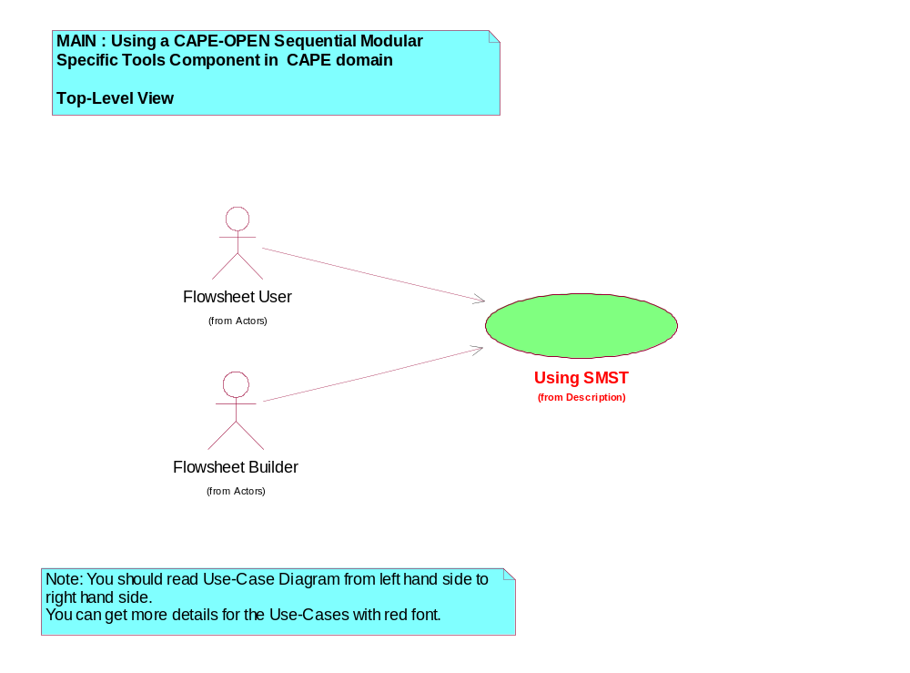
Figure 1. Top-Level View (Use Case Diagram)

The first diagram to view for the Use Case View.
From this, go to the Diagrams Package and open the diagrams following this order:
1, 2, 3, 3.1, 3.2, 3.3, 4, 5

Actors Use Case Package

Human Actor Relatioship Use Case Diagram

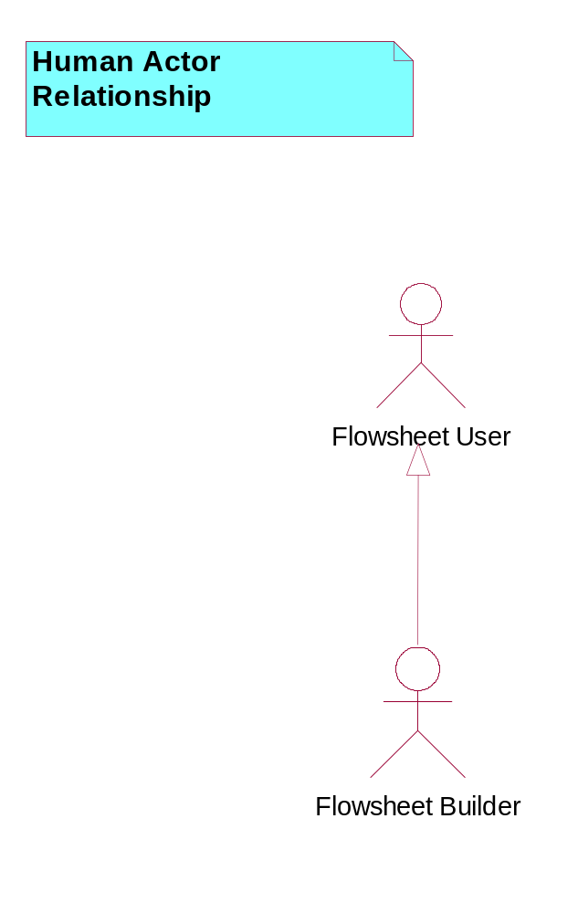
Figure 2. Human Actor Relatioship (Use Case Diagram)

Flowsheet Builder Actor
A human actor.
The person who sets up the flowsheet, the structure of the flowsheet, chooses thermodynamic models, the unit operation models and solver packages.
This person hands over a working flowsheet to the [Flowsheet User]. The Flowsheet Builder can act as a [Flowsheet User].

Flowsheet User Actor
A human actor.
The person who uses an existing flowsheet. This person will put new data into the flowsheet rather than change the structure of the flowsheet.

Description Use Case Package

Administration Use Case Package

Bind to SMST Component Use Case
Bind to SMST Component Use-Case.
Description:
The "bind" process.
Its content strongly depends on the software architecture.
Assumptions:
None.
Exceptions:
None.

Create Analysis Factory Use Case
Create Analysis Factory Use-Case.
Description:
Creates the Analysis factory. It allows to manage the flowsheet solvers.
Assumptions:
None.
Exceptions:
None.

Create Flowsheet Factory Use Case
Create Flowsheet Factory Use-Case.
Description:
Creates the flowsheet factory. It allows to manage the flowsheet.
Assumptions:
None.
Exceptions
None.:

Exit SMST Component Use Case
Exit SMST Component Use-Case.
Description:
The "exit" process.
Its content strongly depends on the software architecture.
Assumptions:
None.
Exceptions:
None.

Give Factory Name Use Case
Give Factory Name Use-Case.
Description:
Gives the name to the factory.
Assumptions:
None.
Exceptions:
None.

Initializing Use Case Package

Building Analysis Use Case Package

Check Available Analysis Use Case
Check Available Analysis Use-Case.
Description:
Checks if a numerical analysis is available. The result is TRUE if a numerical analysis available, otherwise the result is FALSE.
The numerical analysis are PARTITIONING, TEARING, SEQUENCING and (FULL) SEQUENTIAL MODULAR ANALYSIS.
If it is not available (for instance, it is not implemented), the corresponding computation is not possible.
Assumptions:
None.
Exceptions:
None.

Create a Sequential Modular Analysis Use Case
Create a Sequential Modular Analysis Use-Case.
Description:
Creation of the full Sequential Modular Analysis solver.
Assumptions:
[Check Available Analysis] returns true.
Exceptions:
None.

Create Analysis Use Case
Create Analysis Use-Case.
Description:
Creates a numerical analysis.
Assumptions:
None.
Exceptions:
None.

Create a Partioning Analysis Use Case
Create a Partitioning Analysis Use-Case.
Description:
Creation of the Partitioning solver.
Assumptions:
[Check Available Analysis] returns true.
Exceptions:
None.

Create a Sequencing Analysis Use Case
Create a Sequencing Analysis Use-Case.
Description:
Creation of the Sequencing solver.
Assumptions:
[Check Available Analysis] returns true.
Exceptions:
None.

Create a Tearing Analysis Use Case
Create a Tearing Analysis Use-Case.
Description:
Creation of the Tearing solver.
Assumptions:
[Check Available Analysis] returns true.
Exceptions:
None.

Get Numeric Analysis Information Use Case
Get Numeric Analysis Information Use-Case.
Description:
Gets information about the created numerical analysis.
Assumptions:
Success of [Create Analysis].
Exceptions:
None.

Get Analysis Name Use Case
Get Analysis Name Use-Case.
Description:
Gets the analysis name.
Assumptions:
None.
Exceptions:
None.

Get Analysis Maximal Stream Count Use Case
Get Analysis Maximal Stream Count Use-Case.
Description:
Gets the maximal number of streams which can be treated by the analysis.
Assumptions:
None.
Exceptions:
None.

Get Analysis Maximal Unit Count Use Case
Get Analysis Maximal Unit Count Use-Case.
Description:
Gets the maximal number of units which can be treated by the analysis.
Assumptions:
None.
Exceptions:
None.

Get Analysis Maximal Dimensions Use Case
Get Analysis Maximal Dimensions Use-Case.
Description:
Gets the maximal dimension for the analysis.
This value could allow to indicate the limitations imposed by some legacy codes.
Assumptions:
None.
Exceptions:
None.

Give Analysis Name Use Case
Give Analysis Name Use-Case.
Description:
Gives the name of the analysis.
Assumptions:
None.
Exceptions:
None.

Give Analysis Type Use Case
Give Analysis Type Use-Case.
Description:
Gives the type of the analysis which will be created.
The 4 types are : PARTITIONING, TEARING, SEQUENCING and SEQUENTIAL MODULAR ANALYSIS.
Assumptions:
None.
Exceptions:
None.

Building Graph Use Case Package

Add notToBeTorn Property Use Case
Add notToBeTorn Property Use-Case.
Description:
Indicates that the stream should not to be torn during a Tearing Analysis.
This property is used or not by the Tearing analysis, that is implementation dependent.
Assumptions:
None.
Exceptions:
None.

Add Stream Use Case
Add Stream Use-Case.
Description:
In order to build a Process Graph, all streams of the flowsheet must be described by giving the initial Unit each stream comes from, as well as the final Unit each stream goes to.
If these units do not exist, they are created. If the unit(s) already exist(s), that is implementation dependent.
The stream has by default a weight (implementation dependent) and properties (To Be Torn = False and Not To Be Torn = False). Use [Add Weight] and [Add Stream Property] to overwrite them.
Assumptions:
Exceptions:

Add Stream Property Use Case
Add Stream Property Use-Case.
Description:
Adds some properties to a given stream.
Assumptions:
None.
Exceptions:
None.

Add Stream Type Use Case
Add Stream Type Use-Case.
Description:
Adds the type of stream e.g. PROCESS, FEED or PRODUCT. PROCESS means that the stream connects two Units which belong to the Process Graph.
Assumptions:
None.
Exceptions:
None.

Add toBeTorn Property Use Case
Add toBeTorn Property Use-Case.
Description:
Indicates that the stream has to be torn during a Tearing Analysis.
This property is used or not by the Tearing analysis, that is implementation dependent.
Assumptions:
None.
Exceptions:
None.

Add Unit Use Case
Add Unit Use-Case.
Description:
Adds the unit which is the origin of the stream or the unit which is the destination of the stream.
Assumptions:
None.
Exceptions:
None.

Add Weigth Use Case
Add Weigth Use-Case.
Description:
The weight for a specified stream is added.
Weight is a parameter for a Tearing analysis. Its value may be used or not by the Tearing analysis, that is implementation dependent.
Assumptions:
None.
Exceptions:
None.

Create Process Graph Use Case
Create Process Graph Use-Case.
Description:
Creates a Process Graph.
Assumptions:
None.
Exceptions:
None.

Get Flowsheet Maximal Dimension Use Case
Get Flowsheet Maximal Dimension Use-Case.
Description:
Gets the maximum dimension for the Process Graph.
This value could be high (the sizeis of integer type) if the memory management is dynamic.
There could be some limitations due to some legacy codes.
Assumptions:
None.
Exceptions:
None.

Get Flowsheet Maximal Stream Count Use Case
Get Flowsheet Maximal Stream Count Use-Case.
Description:
Gets the maximum number of streams which can be obtained with [Add Stream].
Assumptions:
None.
Exceptions:
None.

Get Flowsheet Maximal Unit Count Use Case
Get Flowsheet Maximal Unit Count Use-Case.
Description:
Getting the maximum number of units which can be completed with [Add Unit].
Assumptions:
None.
Exceptions:
None.

Give Process Graph Name Use Case
Give Process Graph Name Use-Case.
Description:
Gives a name to the created Process Graph.
Assumptions:
None.
Exceptions:
None.

Remove Stream Use Case
Remove Stream Use-Case.
Description:
Removes a stream from the Process Graph.
If the initial unit of the removed stream is not used by another stream, the unit is removed.
If the final unit of the removed stream is not used by another stream, the unit is removed.
Assumptions:
The stream was added by the [Add Stream].
Exceptions:
None.

Remove Stream Property Use Case
Remove Stream Property Use-Case.
Description:
Removes a Stream property such as the stream type, the to Be Torn Property and the Not To Be Torn Property.
Assumptions:
None.
Exceptions:
None.

Remove Unit Use Case
Remove Unit Use-Case.
Description:
Removes a Unit.
Assumptions:
None.
Exceptions:
None.

Remove Weigth Use Case
Remove Weigth Use-Case.
Description:
Removes the weigth given to a stream.
Assumptions:
None.
Exceptions:
None.

Displaying Graph Use Case Package

Get Final Unit Use Case
Get Final Unit Use-Case.
Description:
The destination of the directed stream.
Assumptions:
Exceptions:

Get Initial Unit Use Case
Get Initial Unit Use-Case.
Description:
The origine of the directed stream.
Assumptions:
Exceptions:

Get notToBeTorn Property Use Case
Get notToBeTorn Property Use-Case.
Description:
Assumptions:
Exceptions:

Get Process Graph Name Use Case
Get Process Graph Name Use-Case.
Description:
Gets the name of a Process Graph.
Assumptions:
None.
Exceptions:
None.

Get Set of Streams Use Case
Get Set of Streams Use-Case.
Description:
Gets the set of streams.
Assumptions:
None.
Exceptions:
None.

Get Set of Units Use Case
Get Set of Units Use-Case.
Description:
Assumptions:
Exceptions:

Get Stream Connection Use Case
Get Stream Connection Use-Case.
Description:
Gets the origin of the directed stream and
the destination of the directed stream.
Assumptions:
None.
Exceptions:
None.

Get Stream Count Use Case
Get Stream Count Use-Case.
Description:
Gets the number of streams.
Assumptions:
None.
Exceptions:
None.

Get Stream Information Use Case
Get Stream Information Use-Case.
Description:
Gets information on Streams included in the Process Graph.
Assumptions:
None.
Exceptions:
None.

Get Stream Property Use Case
Get Stream Property Use-Case.
Description:
Gets properties of a stream.
The properties are: the type of the stream (PROCESS, FEEF or PRODUCT), the To Be Torn property (False or True) and the Not To Be Torn property (False or True).
Assumptions:
None.
Exceptions:
None.

Get Stream Type Use Case
Get Stream Type Use-Case.
Description:
Assumptions:
Exceptions:

Get Stream Weigth Use Case
Get Stream Weigth Use-Case.
Description:
Gets the weigth of a stream.
Assumptions:
None.
Exceptions:
None.

Get toBeTorn Property Use Case
Get toBeTorn Property Use-Case.
Description:
Assumptions:
Exceptions:

Get Unit Count Use Case
Get Unit Count Use-Case.
Description:
Assumptions:
Exceptions:

Get Unit Information Use Case
Get Unit Information Use-Case.
Description:
Gets information on the Units included in the Process Graph.
Information pertains to the number of units and to the set of units.
Assumptions:
None.
Exceptions:
None.

Building a Partition Graph Use Case
Building a Partition Graph Use-Case.
Description:
Builds a Process Graph which is a flowsheet with one partition.
A partition is a Maximum Cycle Network.
Assumptions:
None.
Exceptions:
None.

Building an Open Partition Graph Use Case
Building an Open Partition Graph Use-Case.
Description:
Builds an Open Partition Graph which is a flowsheet with one opened partition.
A partition is a Maximum Cycle Network.
Assumptions:
None.
Exceptions:
None.

Building a Process Graph Use Case
Building a Process Graph Use-Case.
Description:
Builds a Process Graph. The Process Graph may be any flowsheet.
Assumptions:
The flowsheet contains at least one stream.
Exceptions:
None.

Building a Numeric Analysis Use Case
Building a Numeric Analysis Use-Case.
Description:
Builds a numerical analysis such as the Full Sequential Modular Analysis, the Partitioning Analysis, the Tearing Analysis or the Sequencing Analysis.
Assumptions:
None.
Exceptions:
None.

Displaying a Partition Graph Use Case
Displaying a Partition Graph Use-Case.
Description:
Displays the characteristics of a Partition Graph.
Assumptions:
None.
Exceptions:
None.

Displaying an Open Partition Graph Use Case
Displaying an Open Partition Graph Use-Case.
Description:
Displays the characteristics of an Open Process Graph.
Assumptions:
None.
Exceptions:
None.

Displaying Process Graph Use Case
Displaying Process Graph Use-Case.
Description:
Displays the characteristics of a Process Graph.
Assumptions:
Success of [Building a Process Graph]
Exceptions:
None.

Get Initial Graph Use Case
Get Initial Process Graph Use-Case.
Description:
Gets the "parent" graph from which the graph has been created.
A Graph B can be generated from the analysis results of a Graph A. The Graph B keeps in mind the "parent" Graph A which has created it. This Use-Case gives this "parent" Graph. If this "parent" Graph does not exist, a null value is returned.
Assumptions:
None.
Exceptions:
None.

Performing Use Case Package

Check Consistency Use Case
Check Consistency Use-Case.
Description:
Checks the data consistency before an analysis computation.
For a Tearing Analysis, checks that the flowsheet has one Partition.
For a Seqencing Analysis, checks that the flowsheet has no cycle.
Other checks would be implementation dependent.
Assumptions:
None.
Exceptions:
None.

Choose Numeric Analysis Use Case
Choose Numeric Analysis Use-Case.
Description:
Chooses a created numerical analysis.
Assumptions:
None.
Exceptions:
None.

Give Open Partition Graph Use Case
Give Open Partition Graph Use-Case.
Description:
Gives the Open Partition Graph to be analysed.
Assumptions:
None.
Exceptions:
None.

Give Partition Graph Use Case
Give Partition Graph Use-Case.
Description:
Gives the Partition Graph to be analysed.
Assumptions:
None.
Exceptions:
None.

Give Process Graph Use Case
Give Process Graph Use-Case.
Description:
Gives the Process Graph to be analysed.
Assumptions:
None.
Exceptions:
None.

Perfom Sequential Modular Analysis Use Case
Perform Sequential Modular Analysis Use-Case.
Description:
Performs a (Full) Sequential Modular Analysis on a flowsheet.
Assumptions:
None.
Exceptions:
None.

Perform Partitioning Analysis Use Case
Perform Partitioning Analysis Use-Case.
Description:
Performs the Partitioning and Ordering Analysis on a flowsheet.
Assumptions:
None.
Exceptions:
None.

Perform Sequencing Analysis Use Case
Perform Sequencing Analysis Use-Case.
Description:
Performs a Sequencing Analysis on a flowsheet.
Assumptions:
None.
Exceptions:
None.

Perform Tearing Analysis Use Case
Perform Tearing Analysis Use-Case.
Description:
Performs a Tearing Analysis on a flowsheet.
Assumptions:
None.
Exceptions:
None.

Results Use Case Package

Create a Partition Graph from Partitioning Analysis Result Use Case
Create a Partition Graph from Partitioning Analysis Result Use-Case.
Description:
According to the computation result, from the flowsheet creates and generates a Partition Graph for a specified partition.
The intermediate streams between partitions become FEED or PRODUCT streams of the built Partition Graph. These streams use the External System Representation through [Get External System Representation].
Assumptions:
None.
Exceptions:
None.

Creating an Open Partition Graph from Tearing Analysis Result Use Case
Create an Open Partition Graph from Tearing Analysis Result Use-Case.
Description:
According to the computation result, from the partition creating and generating an Open Partition Graph.
The torn streams are removed from the partition in order to create and build the Open Partition Graph.
Assumptions:
Exceptions:

Get External System Representation Use Case
Get External System Representation Use-Case.
Description:
Gets the external system.
Assumptions:
None.
Exceptions:
None.

Get Result Partition Count Use Case
Get Result Partition Count Use-Case.
Description:
Getting the number of partitions.
Assumptions:
None.
Exceptions:
None.

Get Result Unit Count in a Partition Use Case
Get Result Unit Count in a Partition Use-Case.
Description:
Gets the number of units in a partition.
Assumptions:
None.
Exceptions:
None.

Get Result for a Partition in Partitioning Analysis Use Case
Getting Result for a Partition in Partitioning Analysis Use-Case.
Description:
Gets results for a specified partition after a Partitioning computation.
Assumptions:
None.
Exceptions:
None.

Get Result for a Partition in Sequential Modular Analysis Use Case
Get Result for a Partition in Sequential Modular Analysis Use-Case.
Description:
Gets results for a specified partition after a Full Sequential Modular Analysis computation.
Assumptions:
None.
Exceptions:
None.

Get Result for the Opened Partition in Sequencing Analysis Use Case
Getting Result for the Opened Partition in Sequencing Analysis Use-Case.
Description:
Gets results for the opened partition after a Sequencing computation.
Assumptions:
None.
Exceptions:
None.

Get Result for the Partition in Tearing Analysis Use Case
Getting Result for the Partition in Tearing Analysis Use-Case.
Description:
Gets result for the partition after a Tearing computation.
Assumptions:
None.
Exceptions:
None.

Get Result Set of Unit in a Partition Use Case
Get Resulting Set of Units in a Partition Use-Case.
Description:
Assumptions:
None.
Exceptions:
None.

Get Result Set of Torn Stream in a Partition Use Case
Get Result Set of Torn Stream in a Partition Use-Case.
Description:
Gets the resulting set of torn streams for the partition.
That contains the number of torn streams and the set of torn streams.
Assumptions:
None.
Exceptions:
None.

Get Result Set of Unit in a Partition Use Case
Get Result Set of Unit in a Partition Use-Case.
Description:
Gets the resulting set of units for the partition.
That contains the number of units and the set of units.
Assumptions:
None.
Exceptions:
None.

Get Result Torn Stream Count in a Partition Use Case
Get Result Torn Stream Count in a Partition Use-Case.
Description:
Assumptions:
Exceptions:

Get Result Torn Stream in a Partition Use Case
Get Result Torn Stream in a Partition Use-Case.
Description:
Assumptions:
None.
Exceptions:
None.

Get Result Unit Use Case
Get Result Unit Use-Case.
Description:
Assumptions:
Exceptions:

Getting Result from Sequential Modular Analysis Use Case
Getting Result from Sequential Modular Analysis Use-Case.
Description:
Gets results from the Full Sequential Modular Analysis.
Assumptions:
None.
Exceptions:
None.

Collaboration Diagram:Getting Result from Sequential Modular Analysis Sequence Diagram

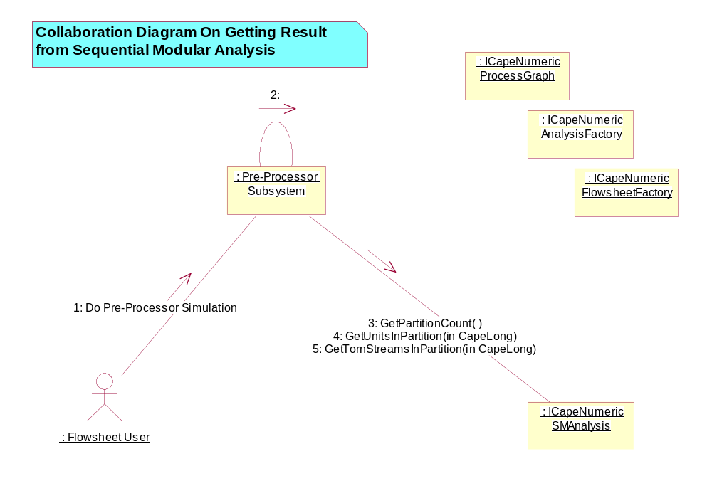
Figure 3. Collaboration Diagram:Getting Result from Sequential Modular Analysis (Sequence Diagram)

A Collaboration Diagram corresponding to the sequence diagram on Getting Result from Sequential Modular Analysis.
The [Flowsheet User] has started the Pre-Processor Simulation.
The [Pre-Processor Subsystem] gets the results from the Sequential Modular Analysis.

Sequence Diagram:Getting Result from Sequential Modular Analysis Sequence Diagram

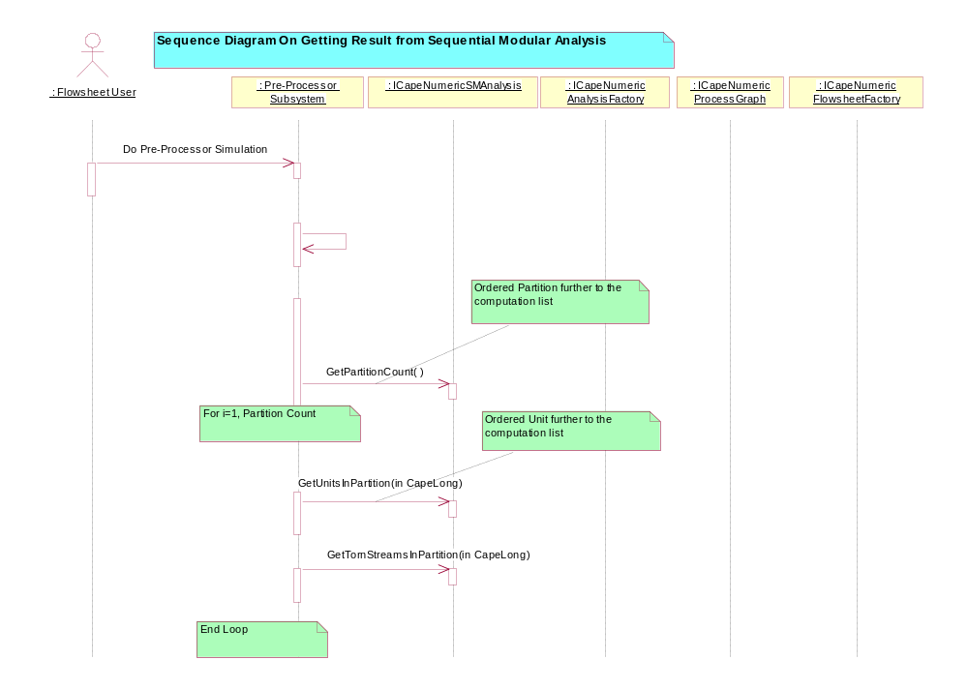
Figure 4. Sequence Diagram:Getting Result from Sequential Modular Analysis (Sequence Diagram)

A Sequence Diagram.
This is a possible scenario of [Getting Result from Sequential Modular Analysis] Use-Case.
The [Flowsheet User] has started the Pre-Processor Simulation.
The [Pre-Processor Subsystem] gets the results from the Sequential Modular Analysis.

Getting Result from Tearing Analysis Use Case
Getting Result fromTearing Analysis Use-Case.
Description:
Gets results from the Tearing Analysis.
Assumptions:
None.
Exceptions:
None.

Collaboration Diagram:Collaboration Diagram:Getting Result from Tearing Analysis Sequence Diagram

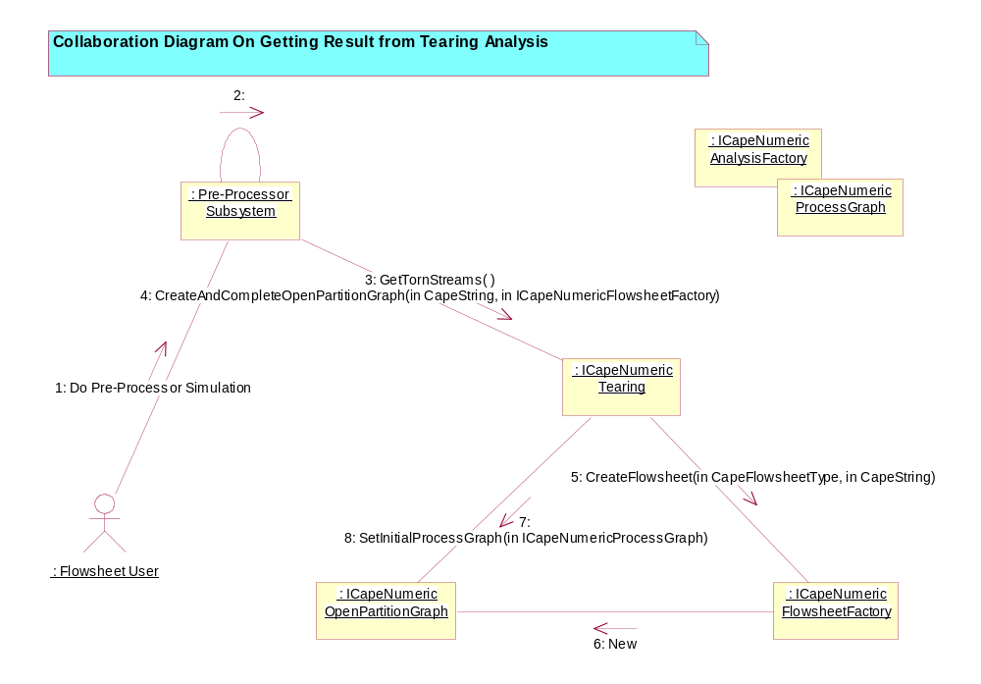
Figure 5. Collaboration Diagram:Collaboration Diagram:Getting Result from Tearing Analysis (Sequence Diagram)

A Collaboration Diagram corresponding to the sequence diagram on Getting Result from Tearing Analysis.
The [Flowsheet User] has started the Pre-Processor Simulation.
The [Pre-Processor Subsystem] gets the results from the Tearing Analysis and creates an Open Partition Graph from these results.

Sequence Diagram:Getting Result from Tearing Analysis Sequence Diagram

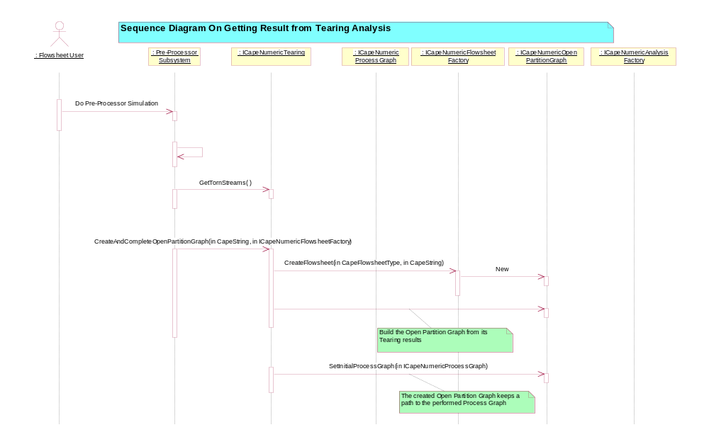
Figure 6. Sequence Diagram:Getting Result from Tearing Analysis (Sequence Diagram)

A Sequence Diagram.
This is a possible scenario of [Getting Result from Tearing Analysis] Use-Case.
The [Flowsheet User] has started the Pre-Processor Simulation.
The [Pre-Processor Subsystem] gets the results from the Tearing Analysis and creates an Open Partition Graph from these results.

Getting Result from Partitioning Analysis Use Case
Getting Result from Partitioning Analysis Use-Case.
Description:
Gets results from Partitioning Analysis.
Assumptions:
None.
Exceptions:
None.

Collaboration Diagram:Getting Result from Partitioning Analysis Sequence Diagram

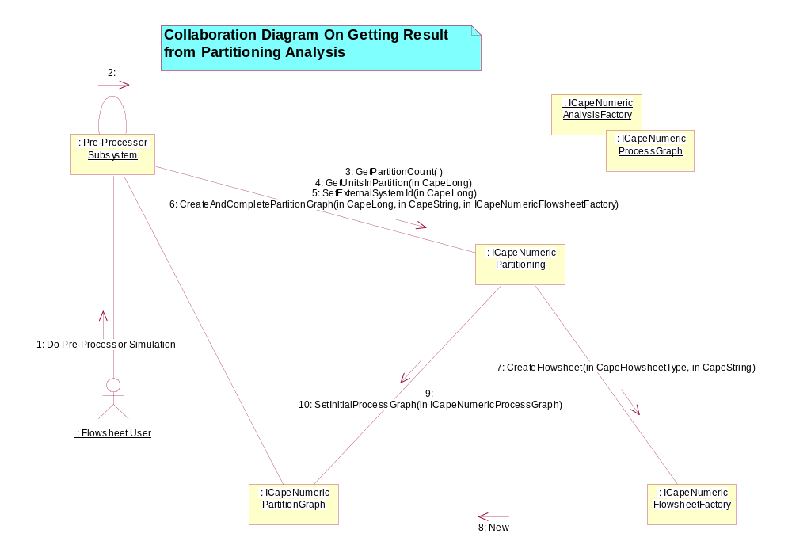
Figure 7. Collaboration Diagram:Getting Result from Partitioning Analysis (Sequence Diagram)

A Collaboration Diagram corresponding to the sequence diagram on Getting Result from Partitioning Analysis.
The [Flowsheet User] has started the Pre-Processor Simulation.
The [Pre-Processor Subsystem] gets the results from the Partitioning Analysis and creates Partition Graphs from these results.

Sequence Diagram:Getting Result from Partitioning Analysis Sequence Diagram

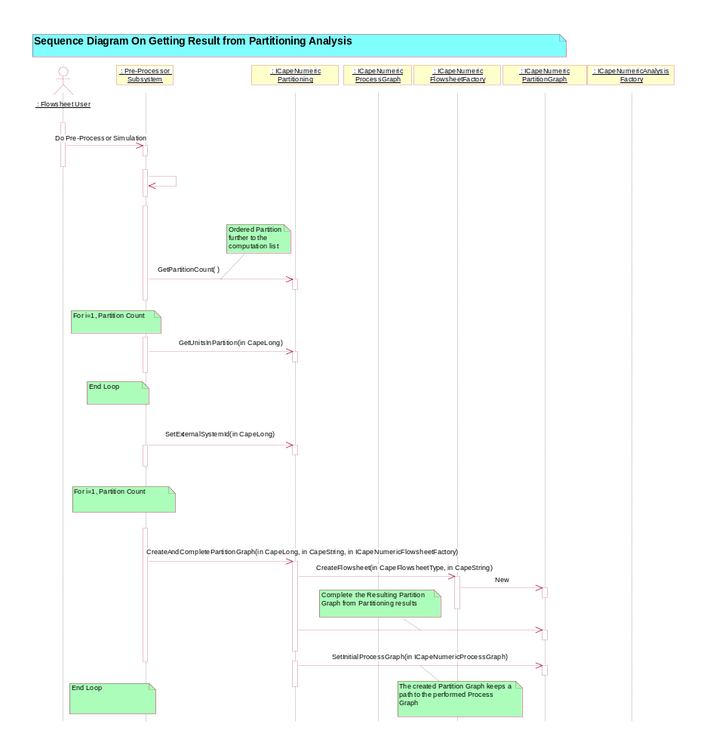
Figure 8. Sequence Diagram:Getting Result from Partitioning Analysis (Sequence Diagram)

A Sequence Diagram.
This is a possible scenario of [Getting Result from Partitioning Analysis] Use-Case.
The [Flowsheet User] has started the Pre-Processor Simulation.
The [Pre-Processor Subsystem] gets the results from the Partitioning Analysis and creates Partition Graphs from these results.

Getting Result from Sequencing Analysis Use Case
Getting Result from Sequencing Analysis Use-Case.
Description:
Gets results from the Sequencing Analysis.
Assumptions:
None.
Exceptions:
None.

Collaboration Diagram:Getting Result from Sequencing Analysis Sequence Diagram

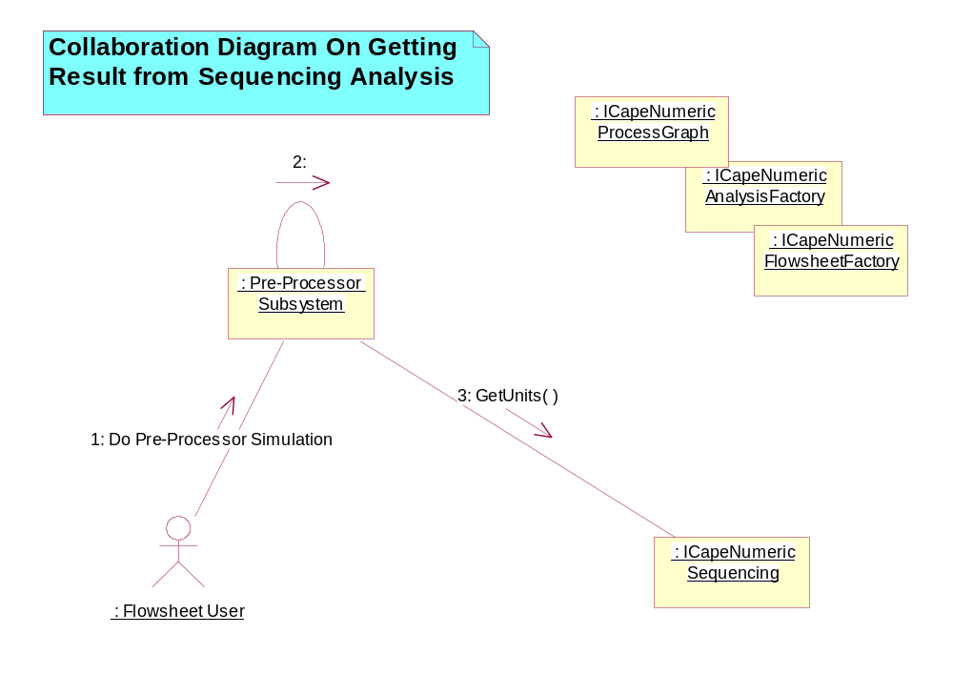
Figure 9. Collaboration Diagram:Getting Result from Sequencing Analysis (Sequence Diagram)

A Collaboration Diagram corresponding to the sequence diagram on Getting Result from Sequencing Analysis.
The [Flowsheet User] has started the Pre-Processor Simulation.
The [Pre-Processor Subsystem] gets the results from the Sequencing Analysis.

Sequence Diagram:Getting Result from Sequencing Analysis Sequence Diagram

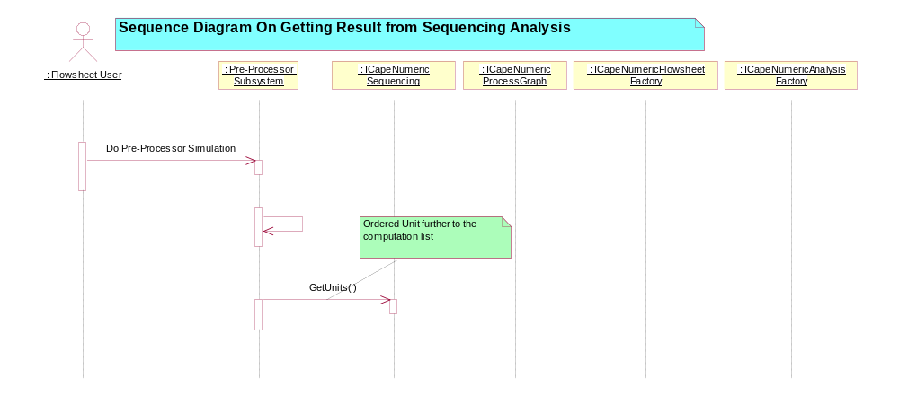
Figure 10. Sequence Diagram:Getting Result from Sequencing Analysis (Sequence Diagram)

A Sequence Diagram.
This is a possible scenario of [Getting Result from Sequencing Analysis] Use-Case.
The [Flowsheet User] has started the Pre-Processor Simulation.
The [Pre-Processor Subsystem] gets the results from the Sequencing Analysis.

Give Open Partition Graph Name Use Case
Give Open Partition Graph Name Use-Case.
Description:
Assumptions:
None.
Exceptions:
None.

Give Partition Graph Name Use Case
Give Partition Graph Name Use-Case.
Description:
Assumptions:
Exceptions:

Manage External System Use Case
Manage External System Use-Case.
Description:
Manages the external system. The external system is used for FEED and PRODUCT streams.
The external system is the original unit for FEED stream.
The external system is the final unit for PRODUCT stream.
Assumptions:
None.
Exceptions:
None.

Set External System Representation Use Case
Set External System Representation Use-Case.
Description:
Sets the external system.
Assumptions:
None.
Exceptions:
None.

Getting and Handling Results Use Case
Getting and Handling Results Use-Case.
Description:
The Flowsheet User gets and handles results from the computation.
Assumptions:
Success of [Performing]
Exceptions:
None.

Initializing Use Case
Initializing Use-Case.
Description:
The [Flowsheet Builder] builds a Graph, may display this Graph and builds a numerical Analysis.
Assumptions:
Success of [Performing Administration Tasks]
Exceptions:
None.

Collaboration Diagram:Initializing Sequence Diagram

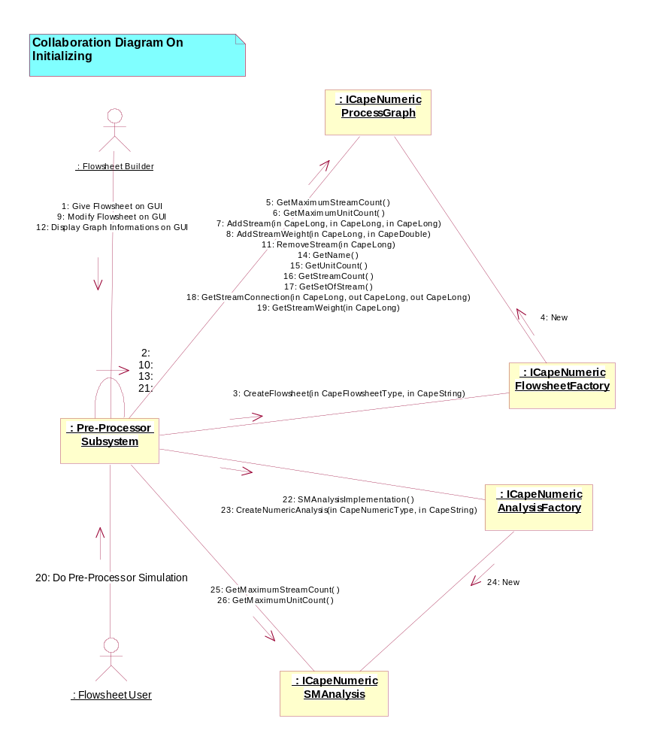
Figure 11. Collaboration Diagram:Initializing (Sequence Diagram)

The Collaboration Diagram corresponding to the Sequence Diagram on Initializing GAT.
The [Flowsheet Builder] interacts with the CAPE Simulator through its GUI. The Simulator uses a CO SMST Component in order to perform some Pre-Processor functions.
The [Flowsheet Builder] builds the flowsheet, modifies the flowsheet, displays the modified flowsheet and the [Flowsheet User] launches the Pre-Processor Simulation.
The [Pre-Processor Subsystem] translates these interactions to the CO SMST Component.
It creates a Process Graph from the Flowsheet Factory and it completes it. It creates a Sequential Modular Analysis from the Analysis Factory.

Sequence Diagram:Initializing Sequence Diagram

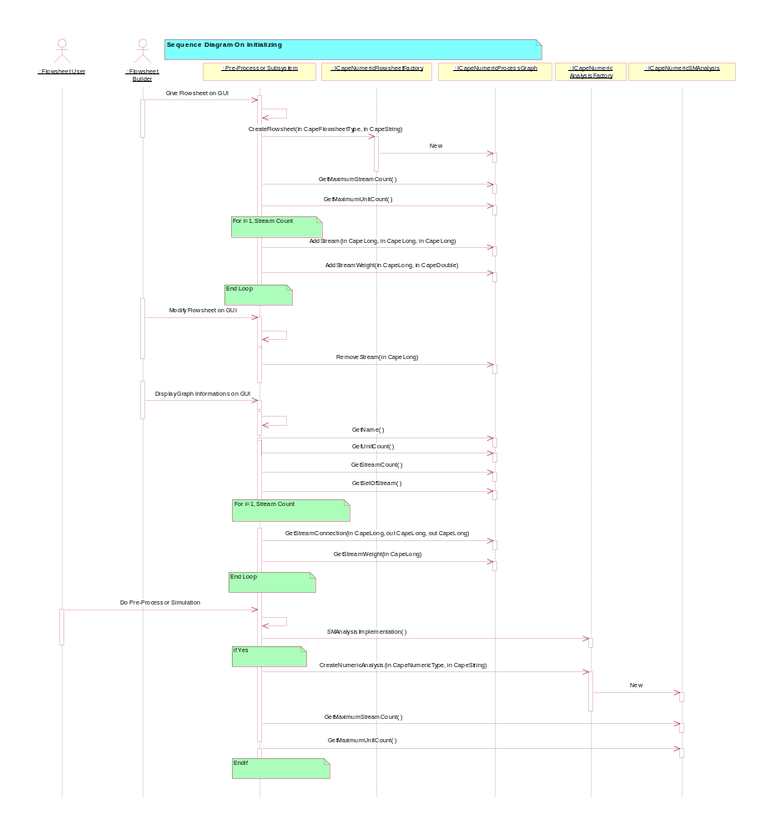
Figure 12. Sequence Diagram:Initializing (Sequence Diagram)

A Sequence Diagram.
This is a possible scenario of [Initializing] Use-Case.
The [Flowsheet Builder] interacts with the CAPE Simulator through its GUI. The Simulator uses a CO SMST Component in order to perform some Pre-Processor functions.
The [Flowsheet Builder] builds the flowsheet, modifies the flowsheet, displays the modified flowsheet and the [Flowsheet User] launches the Pre-Processor Simulation.
The [Pre-Processor Subsystem] translates these interactions to the CO SMST Component.
It creates a Process Graph from the Flowsheet Factory and it completes it. It creates a Sequential Modular Analysis from the Analysis Factory.

Performing Use Case
Performing Use-Case.
Description:
The Flowsheet User performs a numerical analysis among one of the following: Sequential Modular Analysis, Partitioning Analysis, Tearing Analysis, Sequencing Analysis.
Assumptions:
Success of [Initializing]
Exceptions:
None.

Collaboration Diagram:Performing (SMAnalysis) Sequence Diagram

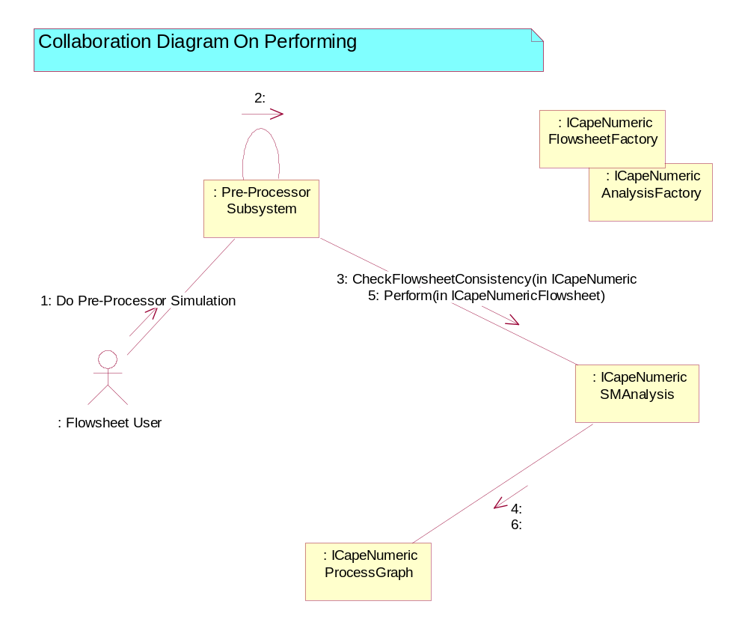
Figure 13. Collaboration Diagram:Performing (SMAnalysis) (Sequence Diagram)

The Collaboration Diagram corresponding to the Sequence Diagram on Performing.
The [Flowsheet User] have started the Pre-Processor Simulation.
The [Pre-Processor Subsystem] checks the data consistency and performs the Sequential Modular Analysis on a Process Graph.

Collaboration Diagram:Performing (Tearing) Sequence Diagram

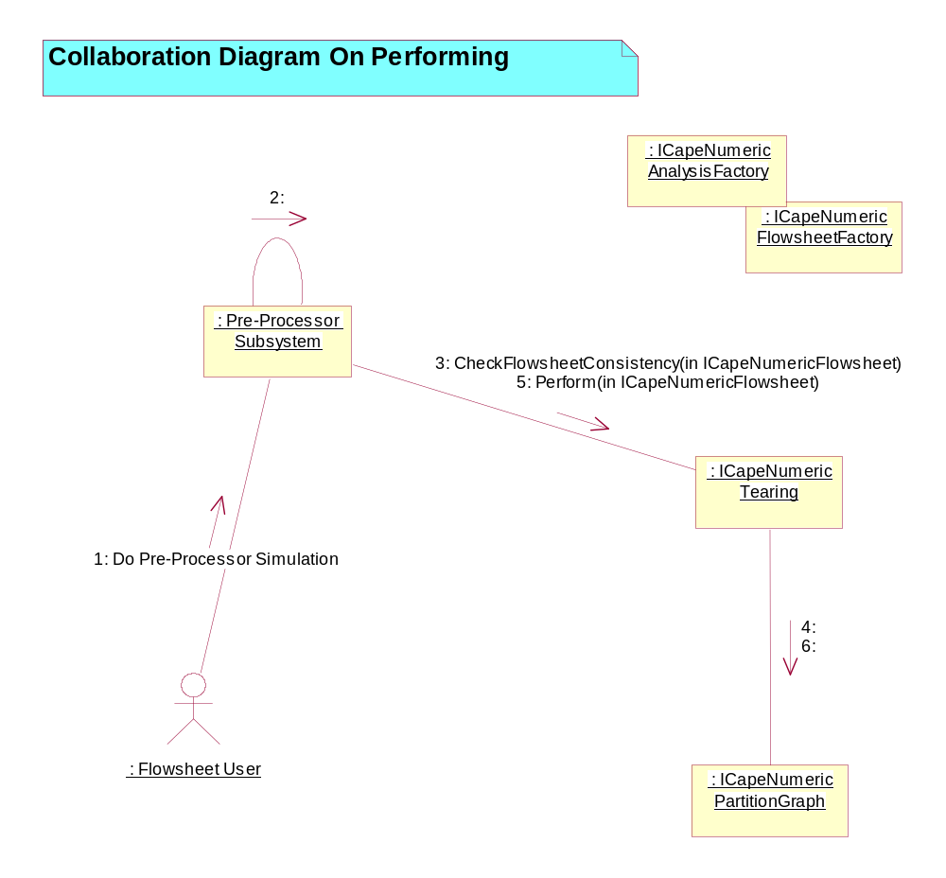
Figure 14. Collaboration Diagram:Performing (Tearing) (Sequence Diagram)

The Collaboration Diagram corresponding to the Sequence Diagram on Performing.
The [Flowsheet User] have started the Pre-Processor Simulation.
The [Pre-Processor Subsystem] checks the data consistency and performs the Tearing Analysis on a Partition Graph.

Sequence Diagram: Performing (Tearing) Sequence Diagram

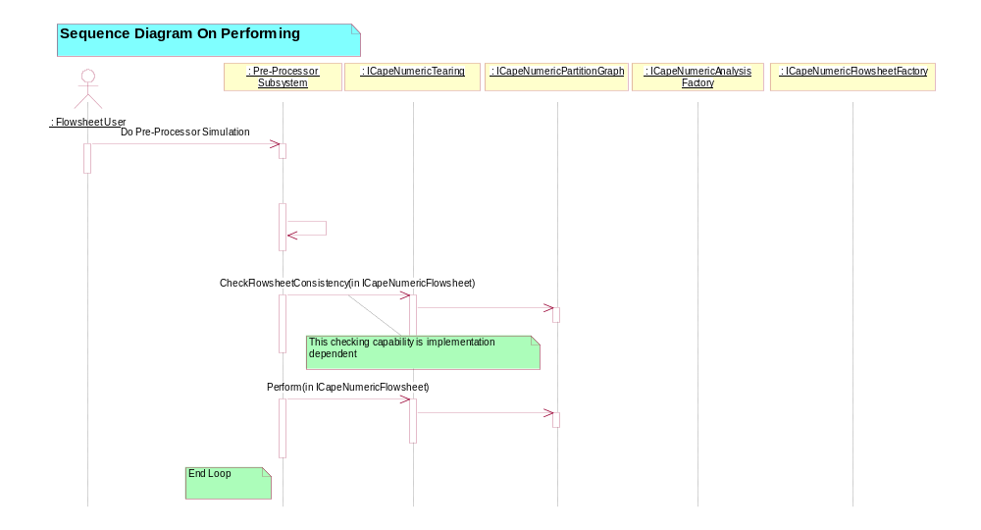
Figure 15. Sequence Diagram: Performing (Tearing) (Sequence Diagram)

A Sequence Diagram.
This is a possible scenario of [Performing] Use-Case.
The [Flowsheet User] have started the Pre-Processor Simulation.
The [Pre-Processor Subsystem] checks the data consistency and performs the Tearing Analysis on a Partition Graph.

Sequence Diagram:Performing (SMAnalysis) Sequence Diagram

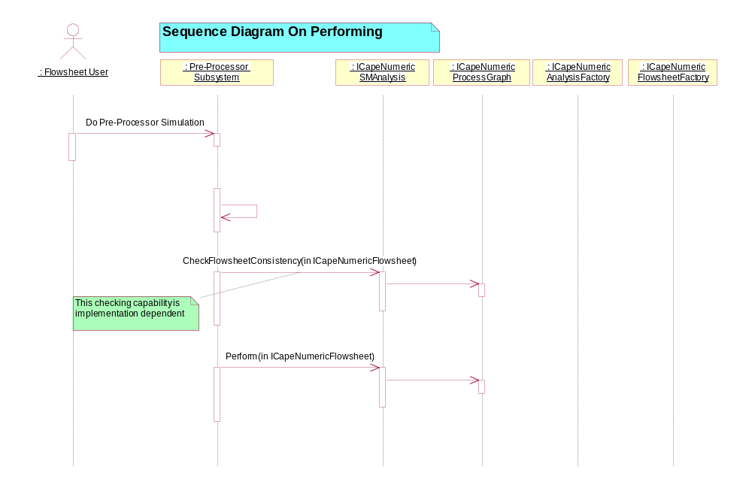
Figure 16. Sequence Diagram:Performing (SMAnalysis) (Sequence Diagram)

A Sequence Diagram.
This is a possible scenario of [Performing] Use-Case.
The [Flowsheet User] have started the Pre-Processor Simulation.
The [Pre-Processor Subsystem] checks the data consistency and performs the Sequential Modular Analysis on a Process Graph.

Performing Administration Tasks Use Case
Performing Administration Tasks Use-Case.
Description:
Performs administration tasks on a CAPE-OPEN SMST Component such as binding process, creating factories, exiting process.
This description is not exhaustive. Other administration activities could occurred.
Assumptions:
None.
Exceptions:
None.

Using SMST Use Case
Using SMST Use-Case.
Description:
The top-level Use-Case: using a CO SMST Component means that you perform administration tasks, initialise, perform and get computation results.
Assumptions:
None.
Exceptions:
None.

Diagrams Use Case Package

0 Interface and Packages Interactions Use Case Diagram

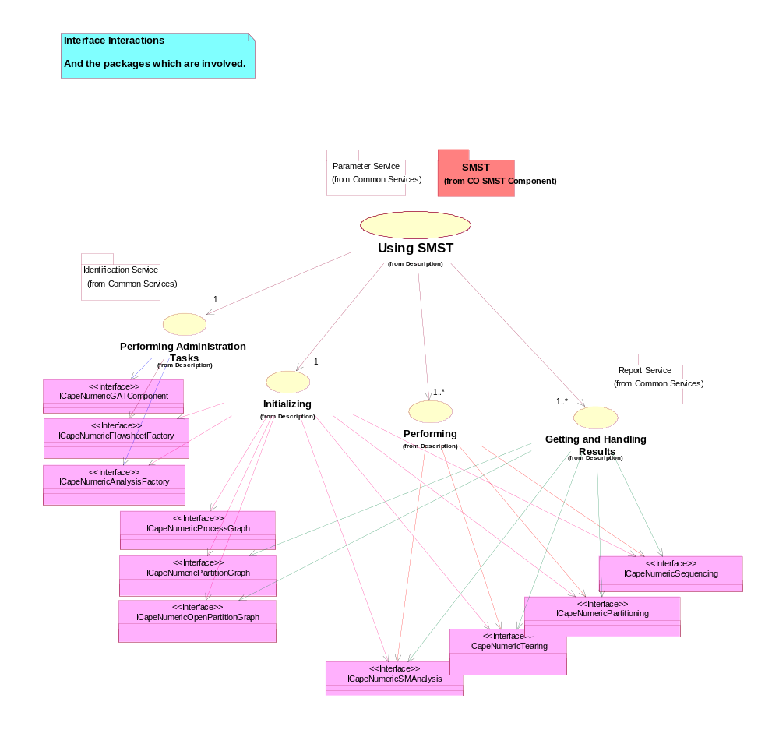
Figure 17. 0 Interface and Packages Interactions (Use Case Diagram)

This diagram shows the link between the Use Case View and the logical view.
Here are the interactions on packages and interface classes for the diagram "1 Using SMST"

1 Using SMST Use Case Diagram

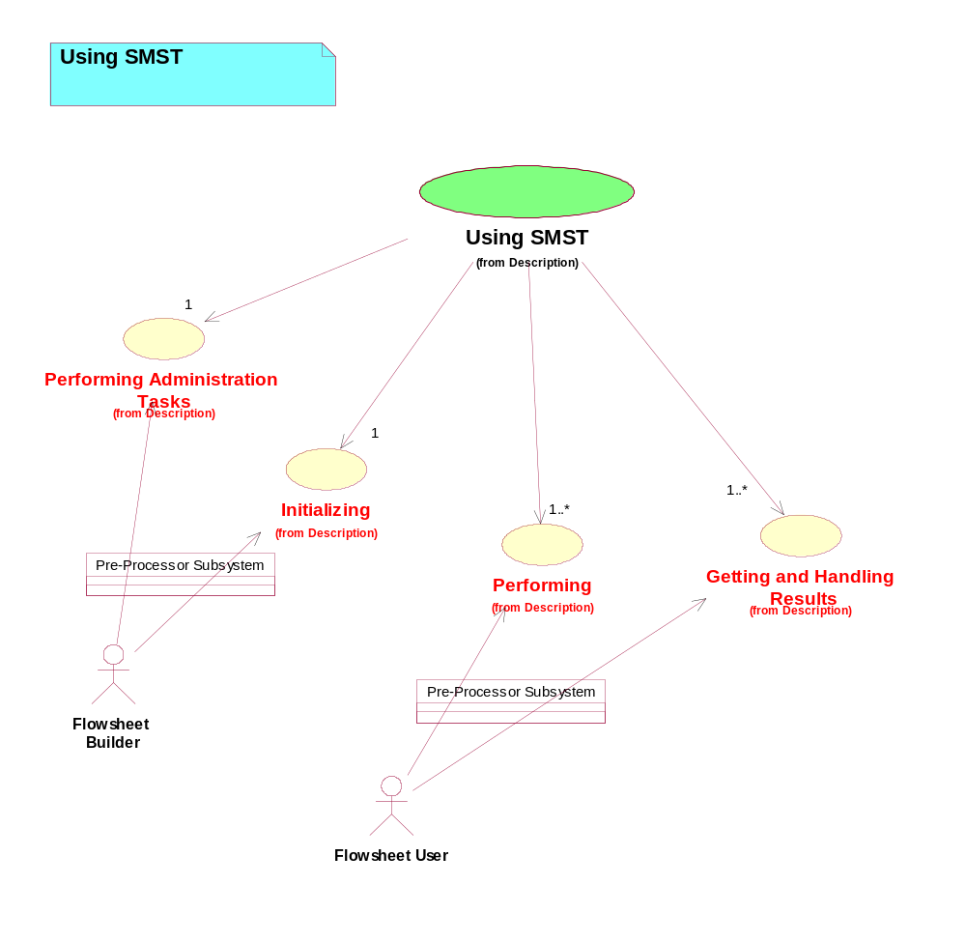
Figure 18. 1 Using SMST (Use Case Diagram)

2 Performing Administration Tasks Use Case Diagram

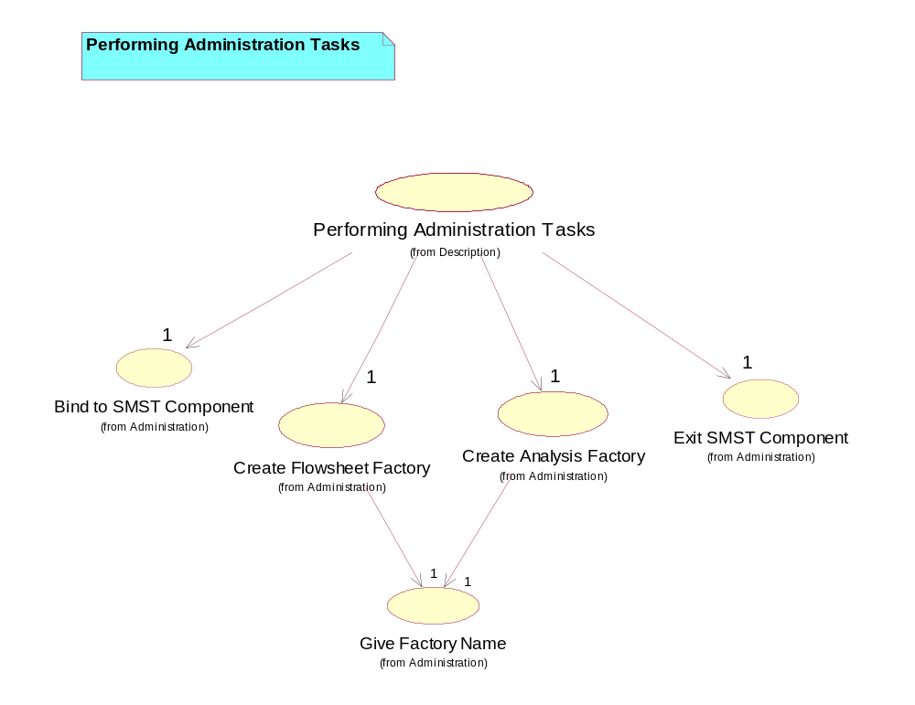
Figure 19. 2 Performing Administration Tasks (Use Case Diagram)

3 Initializing Use Case Diagram

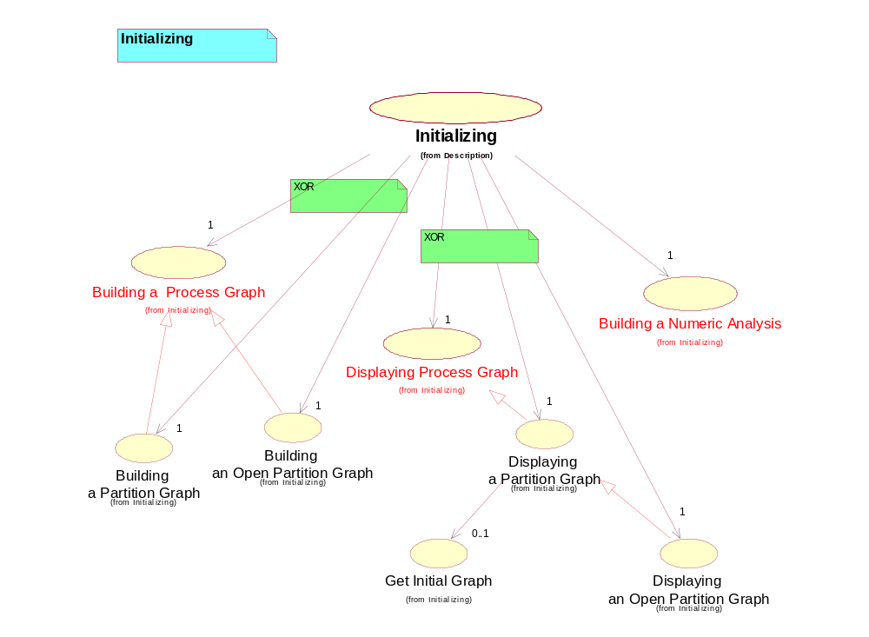
Figure 20. 3 Initializing (Use Case Diagram)

3.1 Building a Process Graph Use Case Diagram

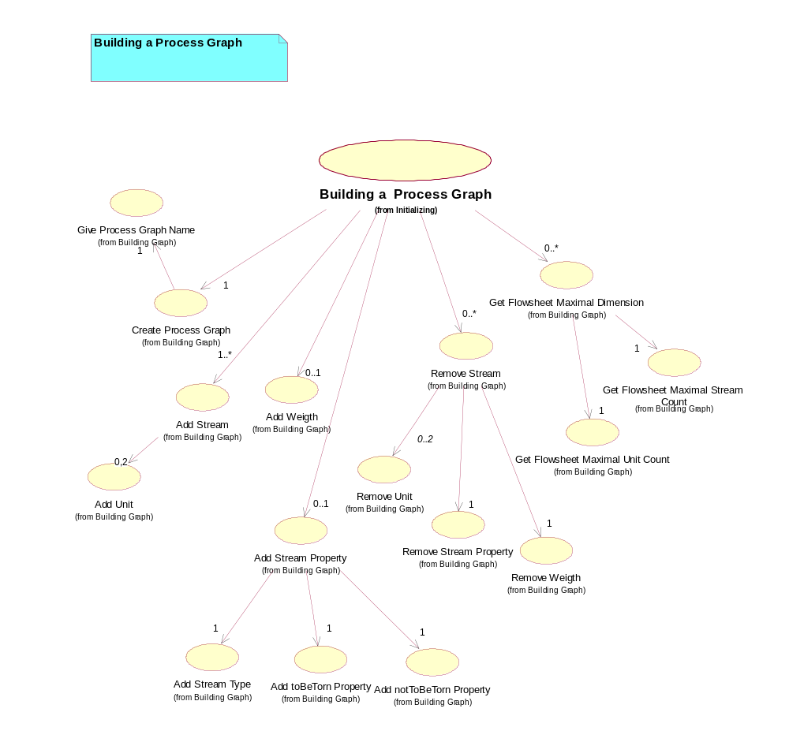
Figure 21. 3.1 Building a Process Graph (Use Case Diagram)

3.2 Building a Numeric Analysis Use Case Diagram

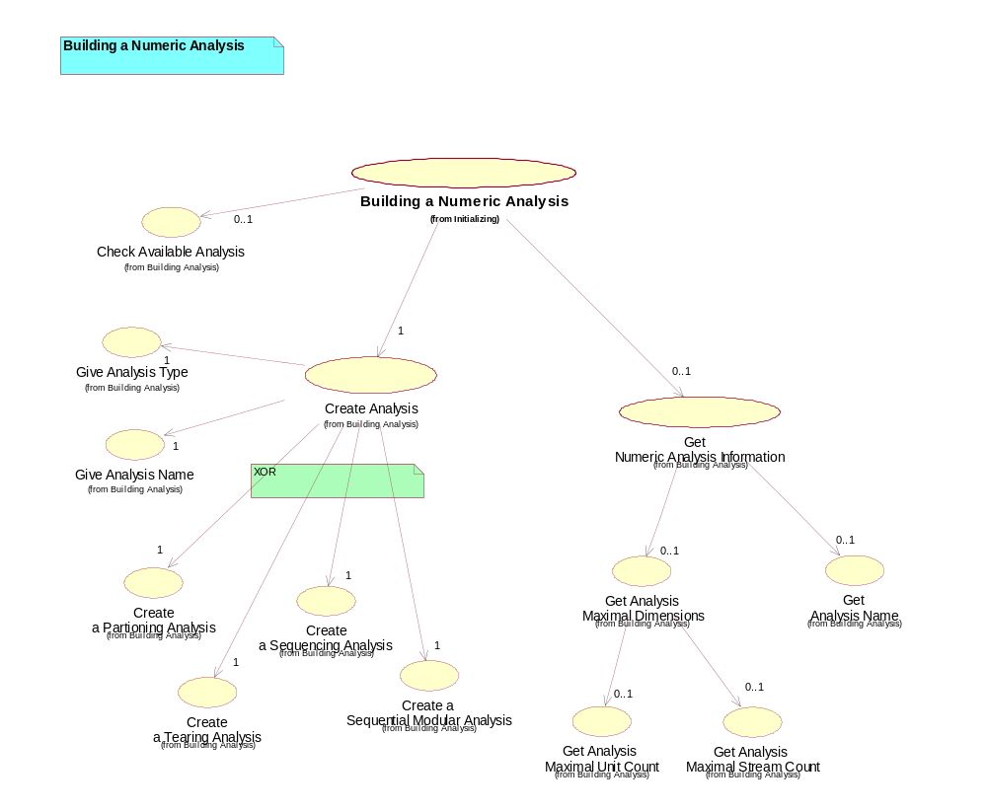
Figure 22. 3.2 Building a Numeric Analysis (Use Case Diagram)

3.3 Displaying Process Graph Use Case Diagram

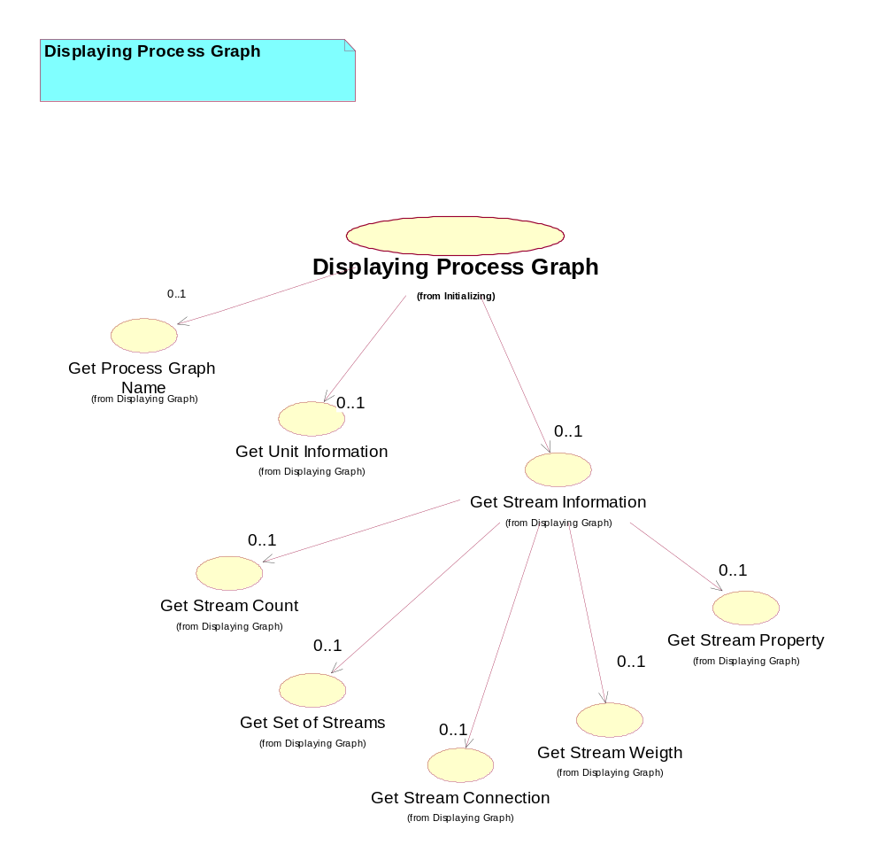
Figure 23. 3.3 Displaying Process Graph (Use Case Diagram)

4 Performing Use Case Diagram

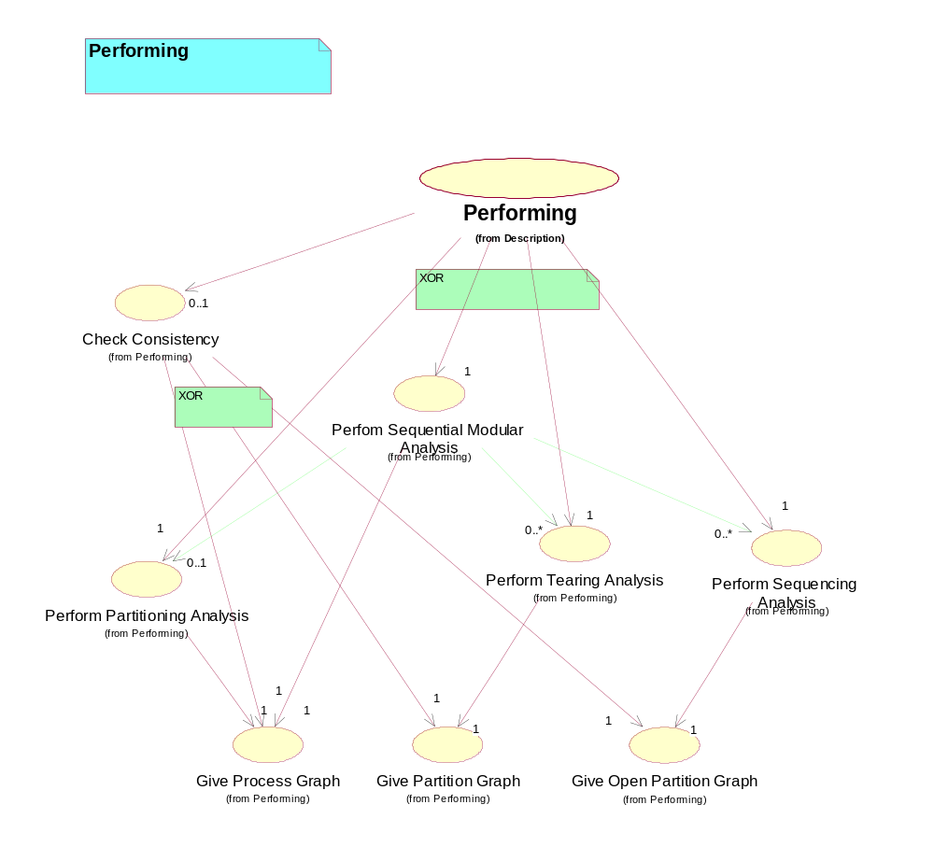
Figure 24. 4 Performing (Use Case Diagram)

5 Getting and Handling Results Use Case Diagram

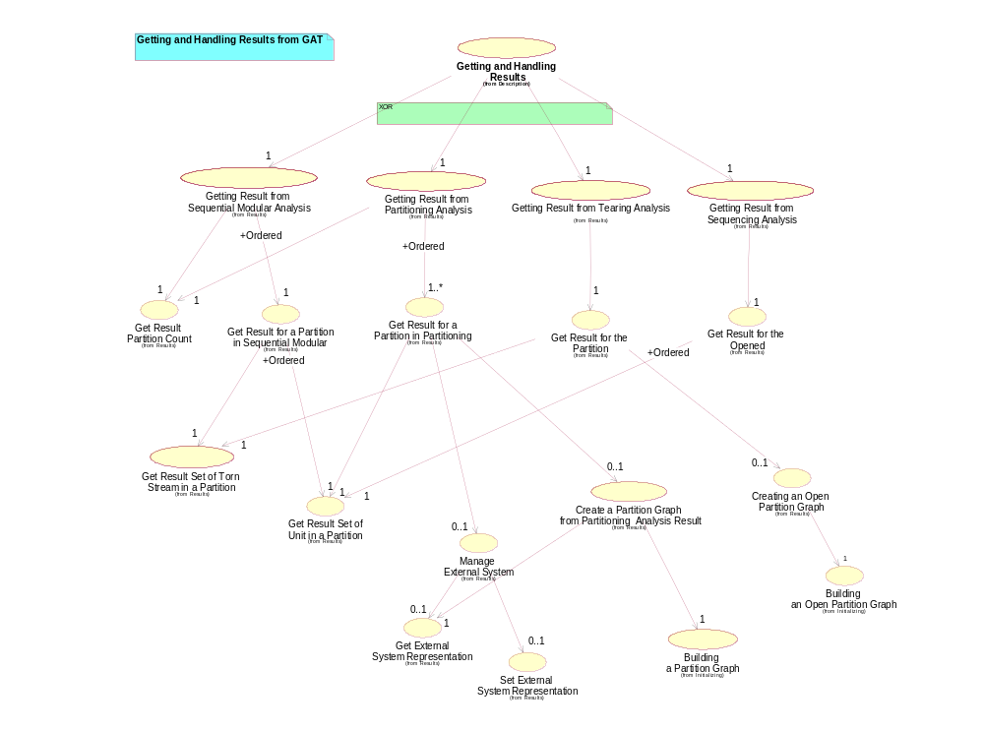
Figure 25. 5 Getting and Handling Results (Use Case Diagram)

